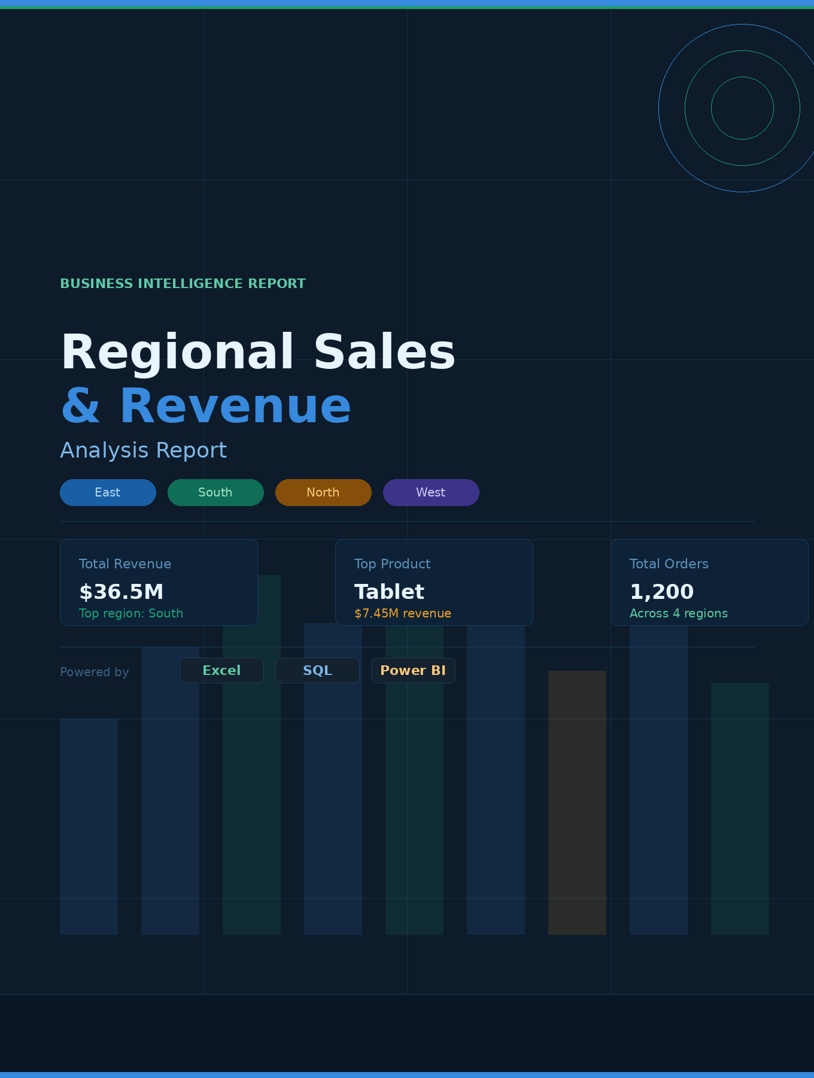

Introduction
The main goal of this report is to analyze sales performance using a dataset containing order details such as product, region, revenue, and date. The analysis aims to identify key trends, top-performing products, and regional performance to support better business decisions.

Data Description
The dataset was taken from an Excel file containing raw sales data. It includes the following columns:
- Order_ID
- Product
- Region
- Revenue
- Date
A separate cleaned dataset named “Cleaned_Data” was created to ensure accuracy while preserving the original data.

Analysis

Data Cleaning
- Created a new sheet (Cleaned_Data) to avoid modifying original data
- Handled missing values:
  - Product → replaced with “Unknown”
  - Region → replaced with most frequent value (“South”)
  - Revenue → replaced with average value (30435.80739)
- Removed extra spaces and standardized text format
- Converted dates into DD-MM-YYYY format
- Removed duplicate records
- Ensured consistency and validation
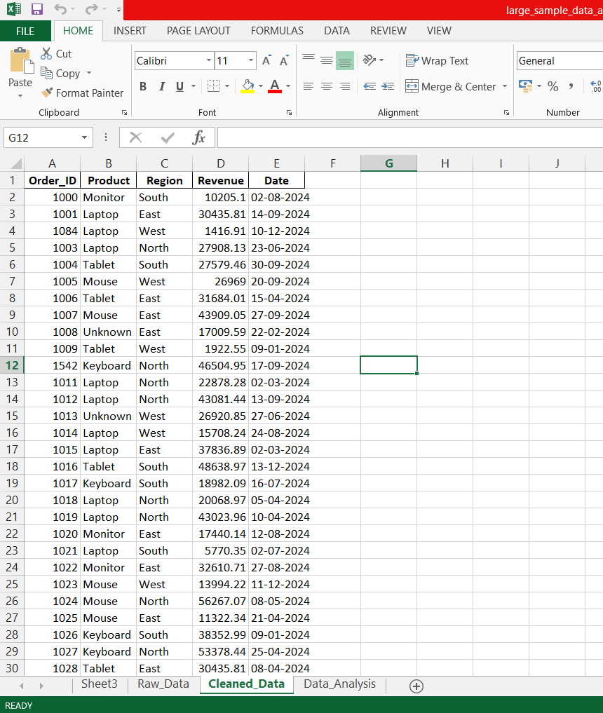

Data Analysis (Excel + SQL + Power BI)
- Total Revenue: 36,522,968.87
- Region-wise distribution (count):
  - East: 275
  - North: 292
  - South: 344
  - West: 289
- Top Products (Revenue):
  - Tablet: 7,450,700.569
  - Mouse: 7,333,008.519
  - Laptop: 6,579,854.814
  - Monitor: 6,531,293.314
  - Keyboard: 6,509,041.121

SQL Queries Used
- Total Revenue calculation
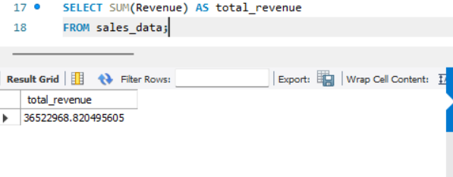
- Revenue by Region
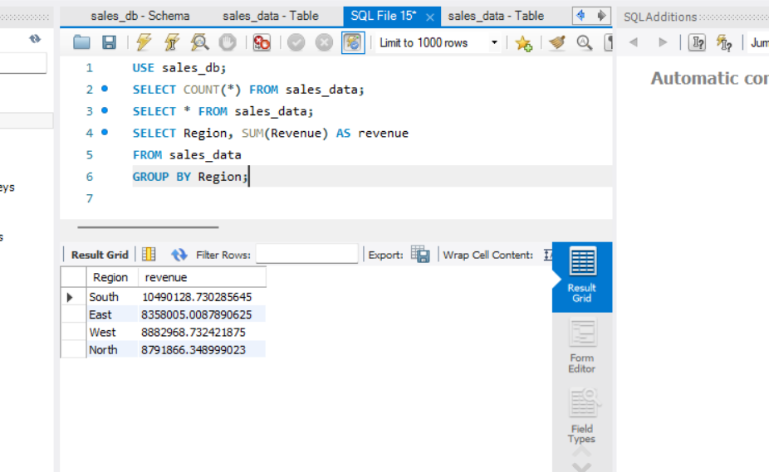
- Top 5 Products
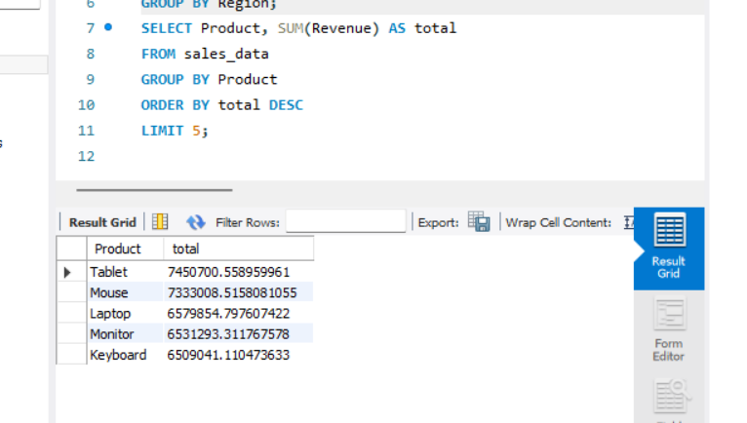
- Average Revenue
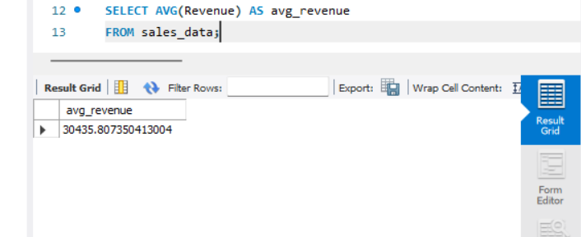
- High-value transactions filtering
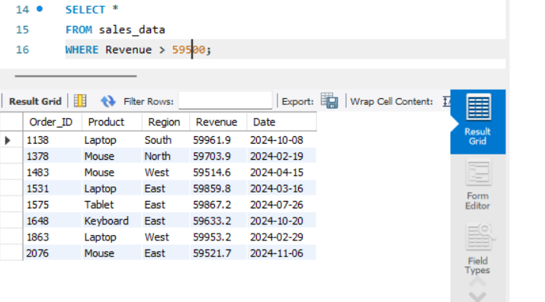

Visualization (Power BI Dashboard)
- Card: Total Revenue
- Bar Chart: Revenue by Region
- Column Chart: Top Products
- Line Chart: Sales Trend
- Slicers: Region & Product filters
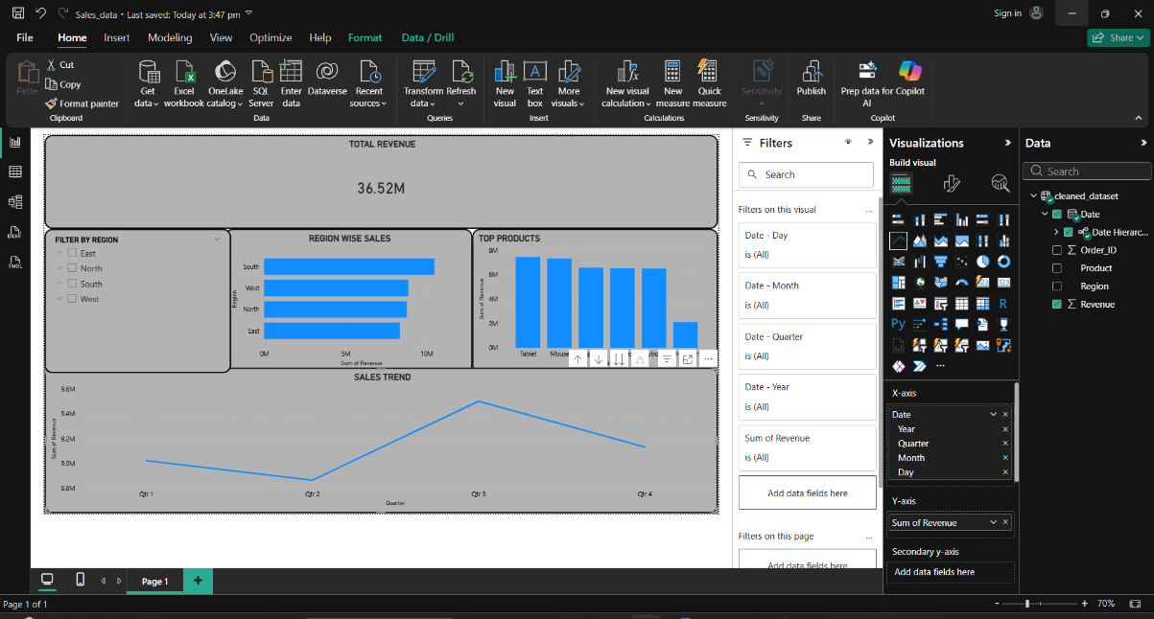

Findings (Insights)
- The South region generates the highest revenue
- Tablet is the top-performing product
- Some regions show lower sales → growth opportunity
- A small number of products contribute most of the revenue
- Sales fluctuate over time (trend variation)
- High-value transactions significantly impact total revenue
- Average revenue helps identify strong-performing transactions

Conclusion
The dataset was successfully cleaned, analyzed, and visualized. The analysis highlights important patterns in sales performance across regions and products. The use of Excel, SQL, and Power BI ensured accurate insights and effective data presentation.

Recommendations
- Focus more on high-performing regions (like South)
- Improve performance in low-performing regions
- Promote top products (especially Tablet)
- Review or improve low-performing products
- Use sales trends to plan marketing and inventory
- Target high-value customers for better retention

Final Note
The analysis provides a strong foundation for business decision-making. By applying these insights and recommendations, the company can improve overall sales performance and profitability.

